Rounding off Numbers

Rounding off numbers are discussed here, where we need to round a number.
(i) If we purchase anything and its cost is $12 and 23¢, the cost is rounded up to it’s nearest $ 12 and 23¢ is left.
(ii) If we purchase another thing and its cost is $15.78. The cost is rounded up to its nearest $16. 0.22 or 22¢ more is taken.
Similarly, any number is taken to its nearest convenient whole number. As 48 is nearer to 50 than 40, so 48 may be rounded up to 50. This is called rounding off the number. In the process of rounding of a number, it is taken to its closest whole number.

Consider the following examples:
1. Round 78 to the nearest multiple of 10.
Solution:
78 is situated between 70 and 80. The middle of 70 and 80 is 75. 78 is nearer to 80 and farther from 70.
2. Round 53 to its nearest multiple of 10.
Solution:
53 is situated between 50 and 60. The middle number between 50 and 60 is 55.
53 is before 55, so it is rounded down to 50.
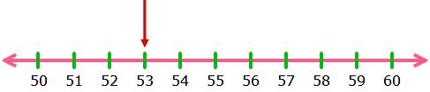
(When any number is situated half way or in the middle of two convenient whole numbers, it is rounded up to the higher whole number)
55 is rounded up to 60, 75 is rounded up to 80
54 is rounded down to 50, 74 is rounded down to 70

